2025 ANNUAL REPORT
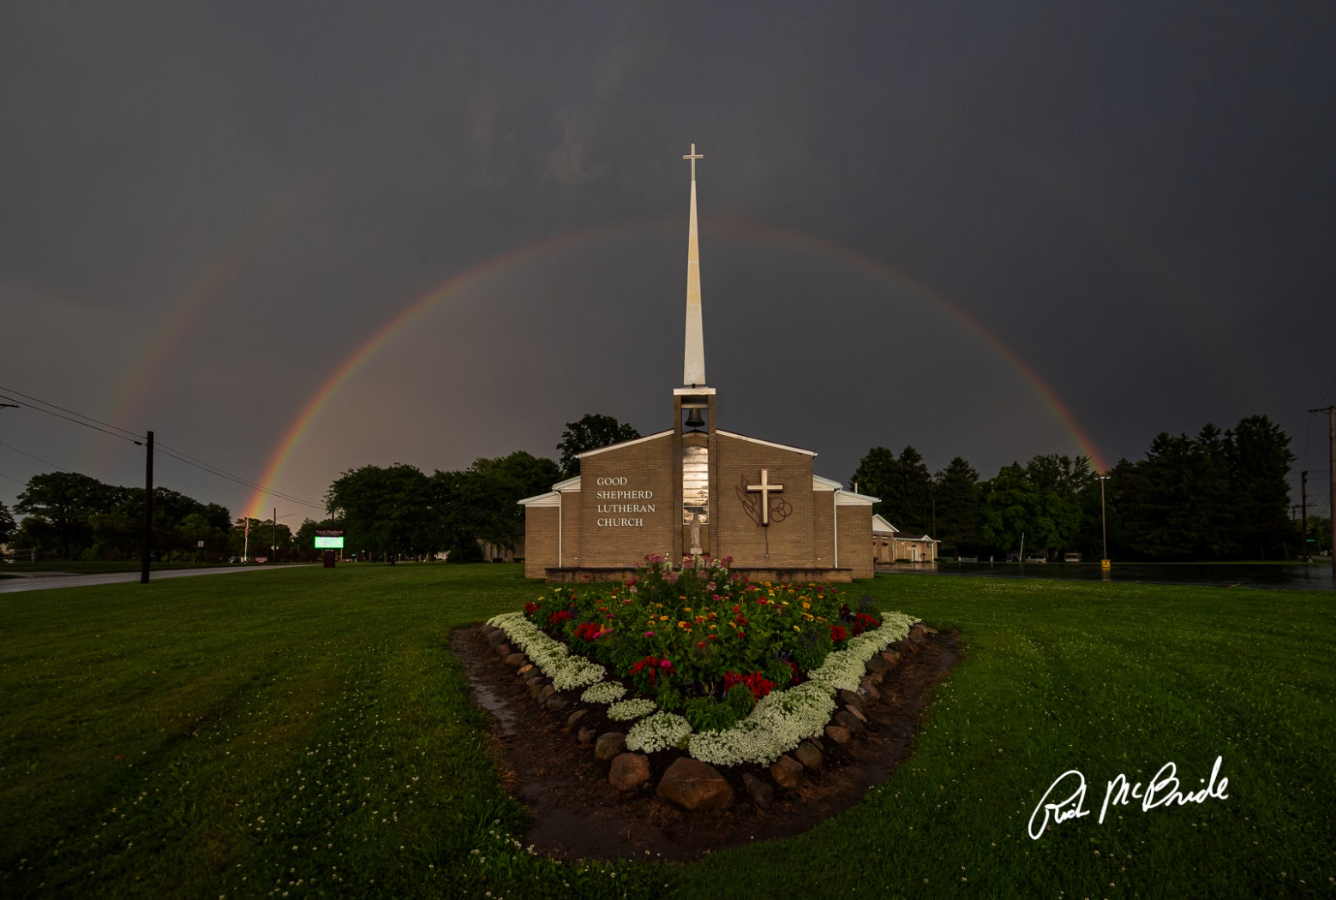

GOOD SHEPHERD LUTHERAN CHURCH
876 GROVE STREET
CONNEAUT, OH 44030
(440) 599-8908
www.gslcc.org

goodshepherd@gwcmail.net

Find us on Facebook and Instagram

MEMBER CONGREGATION OF THE
EVANGELICAL LUTHERAN CHURCH IN AMERICA
NORTHEASTERN OHIO SYNOD

Mission Statement for GSLC:
We are a Christian community, united in God’s call, to serve others, by sharing the love of Christ.
2025 Annual Report- Pastor
The Rev. Joshua Krenz

Grace and peace to you from God our Father, Christ our Brother, and the Holy Spirit our companion.

Leading Worship and Preaching: For 50 of the 52 Sundays with worship services, I presided and preached as per my calling to this congregation. One Sunday – June 29 – was a scheduled vacation day and one Sunday – November 9 – was vacation in Santa Fe. I should note, November 9th was a day of leading worship and preaching but at Christ Lutheran Church in Santa Fe, NM; it is still counted as a vacation day.

During the season of Lent from Ash Wednesday on March 5 through Holy Week and Holy Saturday on April 19, I preached and presided at two Ash Wednesday services, presided at the Mid-Week service each Wednesday (with the exception of the Wednesday in Holy Week), preached and presided for Maundy Thursday, and presided on Good Friday and Holy Saturday as per my calling to this congregation. I, along with other members of the Conneaut Area Ministerial Association (CAMA), organized and participated in two Lenten worship services – Corpus Christi Parish and Conneaut Church of Christ. Along with these two Lenten worship services, CAMA organized and participated in the Annual Stations of the Cross service on Good Friday at Township Park.

Baptisms: This year, I had the honor and privilege to baptize my newest niece, Milly Ester Travis on November 9, 2025.

Funerals: This year, I presided over 3 funerals: Bud Maenpaa, John Chapin, and Jim Monday.

Confirmation/Christian Education: The 2024-2025 Confirmation class began with one student and one adult. After completing the two-year cycle, Arianna Berry was confirmed on Pentecost Sunday. The decision was made to not begin another Confirmation class with only one potential student. Instead, an Adult Sunday School class began discussing the history of the church and with the intentional focus on celebrating the 1700th anniversary of the Nicene Creed. On average, three adults attended until the class concluded prior to vacation in November.

Weddings: I presided over one wedding this year on February 3, 2025. This was a small ceremony held within the sanctuary.

Vacation Bible School: Vacation Bible School (VBS) was organized by the Christian Education department headed by Jennifer Best. She organized a three-night program. While we do try to collaborate with other churches, and this program was opened to the whole Conneaut and surrounding area community, the primary attendees were the regular Good Shepherd Lutheran Church children. My role within this program was to assist as able and to be the pastoral presence.

The Wider Church: In 2025, I decided to skip the All-Ohio Rostered Ministers Gathering held in Columbus, Ohio. I made this decision with the intent to later enroll in LEADERship Ashtabula using the Continuing Education Funds that are set aside as required by the synod. For two years, a member of this congregation has promoted LEADERship Ashtabula with a second promoting it later in 2025. This was a program that I was interested in participating in and 2025 was the year of opportunity for this participation. On May 17th, Synod Assembly was held virtually, which I attended in my office.

The Synod Ecumenical Committee met virtually as needed. I was also nominated and joined the Synod Council. The Synod Council meets only 4 times between Synod Assemblies and I was able to join the first meeting – the second meeting was held the day of a major church event that I could not skip. I also attended all the CAMA meetings as I was able, given a number of Invocations at Conneaut City Council Meetings, and the fleet blessing. As mentioned before, the unfortunate side-effect of rural ministry is the connection to the wider church is lessened. Due to distance, weather, and timing, attending Conference Meetings is not beneficial to Good Shepherd and the congregation.

Other Notes: Throughout the year, I have attended, as able, all the activities happening at Good Shepherd including the weekly, monthly, and annually activities.

In 2025, Church Council and I made the intentional effort to reexamine the Mission Statement for Good Shepherd Lutheran Church. Throughout this process, both the congregation and the community were giving the opportunity to input their ideas and opinions. At the October Congregational Meeting, the attended congregation members decided to retain the current Mission Statement.

Outside of the church building as pastoral responsibilities, I have been attending Paint and Sips, Raffles, Festivals, and other events to help make a presence in Conneaut and surrounding communities. As mentioned above, I have enrolled in LEADERship Ashtabula which continues my education of the county and allows me to make connections that will benefit both this pastor and the congregation of Good Shepherd Lutheran Church. While certain traditional ideas of a pastor are waning, new ideas of what it means to be a pastor continue to be formed, encouraged, and accomplished.

I look forward to what 2026 brings for us and how we, as a Christ centered Church, can minister to and with Conneaut and the surrounding neighborhoods. I know this congregation is full of love, and just one of the reasons I absolutely enjoy and love coming to the church every day. I know God is calling us to do God’s work in the Conneaut area and I know this congregation can reach any task that it placed before it with the help of God and the Holy Spirit with us always.

2025 Annual Report- Church Council

*Serves on finance committee as well
According to the Constitution and Bylaws for Good Shepherd Lutheran Church of Conneaut, Ohio of the Evangelical Lutheran Church in America: C12.02. The members of the Congregation Council except the pastor shall be elected at a legally called meeting of this congregation during the month of December. Their term of office shall be for three (3) years, with the term of office beginning on Second Sunday of January (month and day) and ending on Second Sunday of January (month and day). Newly elected Congregation Council members shall be installed at worship the Second Sunday of January. Such members shall be eligible to serve no more than two three-year terms consecutively.
**C12.03. Should a member’s place on the Congregation Council be declared vacant, the Congregation Council shall elect, by majority vote, a successor until the next annual meeting. Individuals who have served less than one-half of a regular term shall be eligible for nomination and possible election to a full term.

2025 Annual Report- GSLC Office
Jennifer Best

My goal for 2025 was to have a handheld phone to allow me to be more available throughout the church, and not tethered to the desk. This continues to be the goal for 2026. We’ve also cleared out enough drawers this year and I hope in 2026 to get rid of some filing cabinets that we don’t need.

In January 2025, we got a new printer to replace the one we’ve been leasing from LBP and it is expected to save us about a thousand dollars per year.

I would also like to take this time to let everyone know the dates the office will be closed in 2026. Based on the Employee Handbook, I am approved to have nine (9) paid holidays taken the day of or the next working day for New Year’s Day, Easter Monday (Monday after Easter), Memorial Day, Independence Day, Labor Day, Thanksgiving, Christmas Eve, Christmas Day, and the day after Christmas.

I am also permitted eight (8) working days per calendar year granted as vacation during the first through fifth years. I tentatively plan on using these vacation days on February 2nd, June 22nd, October 29th, December 21st, 22nd, 23rd, 30th, and 31st.
Exact dates will be posted in the announcements and calendars as they approach.

I am so thankful for this job, and for all of you.
May you have a blessed new year.

2025 Annual Report- altar guild
Kelly Anthony

The function of Altar Guild is to prepare the altar-chancel area for worship service. On a weekly basis, we clean, take care of the flowers and candles, and arrange for Holy communion. The Altar Guild is also responsible for changing the banners and paraments and preparing for baptisms, funerals, and weddings.

In 2025, the altar and communion were prepared for a total of 106 worship services, including six special services and two funerals. During the year, 2,762 sacraments of communion were received by individuals.

This year saw the retirement of long-time Altar Guild chair, Ruth Brown. Ruth’s 30 plus years of service in this role is greatly appreciated, and her experience and expertise continue to be relied upon. Other members of the 2025 team included Kelly Anthony, Robin Bryant, Susan Combs, Michelle Flower, Marion Patten, Katrina Pavolino, Barb Talan, and Susan Tan. New members are always welcomed.

2025 Annual Report- abiding memorial
Ruth Brown/ Susan Tan

Abiding Memorial deposits made in 2025 were received in Memory and Honor of:
Tom Hall.

Abiding Memorial expenditures in 2025 were:
food pantry AC unit

Deposits in Nov. 6, 2024- Nov. 6, 2025: $1721.24
Expenditures Nov. 6, 2024-Nov. 6, 2025: $1700.45

2025 Annual Report- evangelism
Michelle Logan

I would like to personally thank everyone that has supported our mission this past year. Thank you to: Martha Jayne and Dave Thompson, Barb Talan, Robin Bryant, Sandra Matheny, Suzanne and Mike Malys, Mark Lytle, Nickolas Mason, Emily McQueeney, Ruth Brown, Mary Lou Mosio, Susan Tan, Stacy Racut, Susan and Wes Combs, Sue Robinson, JoAnn Mechling, Janelle Cole, Richard Tulino, Amy Gallagher Sophia Poff, Grace Todaro, Pat and Debbie Andersson. If not for your time and talents the many missions and events would not be possible.
The Evangelism team has had a very busy and rewarding year. We started the year out with co-partnering with the youth group to host a Purse Bingo. It was a big success, with both ministries earning over $1000.00 for each of our missions. We are looking forward to working in partnership with the youth group again on this event.
We held our second All-Community Dinner. We received very positive feedback once again this year and are looking at continuing this dinner in 2026. In May we hosted our annual Spa Day. Attendance has grown this year with much positive feedback. Looking forward to hosting it again in 2026
Once again, this year we opened our parking lots for the 4th of July parking, and of course D-Day parking. Once again, the 4-day parking event helped us raise over $9000.00. We were able to give $20% to the general fund with the rest being split between Outreach, Fishes and Loaves, and Nick’s Closet. D-day parking event was a huge success this year with raising a little shy of $9,000.00. We were able to give 20% to the general fund with the remaining monies divide among the different ministries of Fishes and loaves, and other outreach needs for the community that include: Bowling, Brants Apple Farm, The Annual Candy Crawl, Sunday School Christmas Party. We also partnered with Corpus Christi this year to provide a Community Thanksgiving dinner. We were able to provide 437 meals within our community.
This year we did not adopt families as usual. But we were able through Social Ministry to provide 11 Families with $100.00 Walmart gift cards to help with their Christmas. These funds were made possible from the proceeds from the Fish Dinner that was held during D. Day
In October we held our annual Basket Raffle. Our community has been very supportive of our mission of the church. We had 112 donated items that we were able to auction off, and we had over 80 tickets sold. This event is growing each year, and we are looking forward to next year’s Basket Raffle.
2024 has been a year filled with many blessings and changes for the Fishes and Loaves Ministry. In 2024 due to changes at Country Neighbor and their partnership with the Cleveland food bank, we were able to partner with the Cleveland Food Bank independently from Country Neighbor. This partnership along with our partnership with Country Neighbor has allowed us to continue to meet the needs of our community.
Our Partnership with the Cleveland Food Bank continues to be a blessing. This partnership is for both the Pantry, Nick’s Closet, and the free lunch program. Under this agreement with them we were able to purchase a wide variety of food items at little or no cost. Cleveland provided us with grant money for both food programs this past year to help offset the cost of purchasing items. With this partnership we were able to distribute 132,766 lbs. of food in our pantry and 53,311 pounds of food for the free lunches, that is a total of 186,077 lbs. of food just from the Cleveland food bank; this total reflects an increase of more than %50 over last year of 56,000 pounds of food. In addition, with help from the Clevland food bank we were given the opportunity to partner with Walmart. Under this partnership we receive weekly donations of fresh, frozen and canned/boxed food items. This partnership has provided us with an additional 18,216 lbs. of donated items. Through the Cleveland Food Bank we now have began a partnership with 3 local Dollar General Stores; this past year we have been able to gain additional donations totaling 4,527 pounds. Our partnership with Country neighbor continues. They continue to be a great asset to our programs. We receive on average 1600 lbs. of food from them per month. Our partnership with Cleveland has also provided us with grant money that will help offset the cost of purchasing needed items. In addition, they provided us an opportunity to purchase a new commercial freezer for the pantry through a grant.
We have seen the need continue to grow over the past year. In the year 2024 we served 1611 households in our pantry. This year the total number of households has grown to 1891(see charts below). Though this was a small increase there were several months that we limited services, this included the month of July when only the food pantry was open on Tuesday and we only were open for half the month of Dec. We have this down time so that the entire team has time off for some much need rest. Our partnership with Cleveland has also provided us with an opportunity to purchase hot meals from their kitchen. The cost of purchasing our meals has increased $2.50 per meal. We are able to supplement with free items that are available. These meals are hot and well balanced. We have been able to serve such meals as stuffed Shells, Meat Loaf, Ham, Chicken; and all these meals come with 2 to 3 side dishes. Again, we have seen an increase in the amount of those we are serving. In 2024 we served on average 200 to 220 lunches per week, this year in 2025 we are serving on average 250-281 lunches per week.
As the increased numbers of those that we serve on Saturdays so has the amount of those needing cleaning and hygiene items. To be able to continue supplying these items to the public. Nickolas decided to limit the number of items that they can have to a limit of 4 items per visit.
We would also like to thank the many generous donors that have provided support for this Mission. This includes Susan Tan, Gail Burlingham, the Moose Club, The Elks Club, and the Lake Erie Hose Boosters. Also, the numerous businesses and private that support our events with donations of cash and items for our basket raffle. They total over 70 Businesses within our community and beyond.
As 2025 ends and 2026 begins we are excited at what God might have planned for us. Over the past year we have had such positive input from the community. Our love for neighbors is being felt beyond our walls. This past year we have been blessed with volunteers from the community members from outside of church walls that have shared their time and talents with us. I know that we are doing Gods command to share the love of Christ to others.

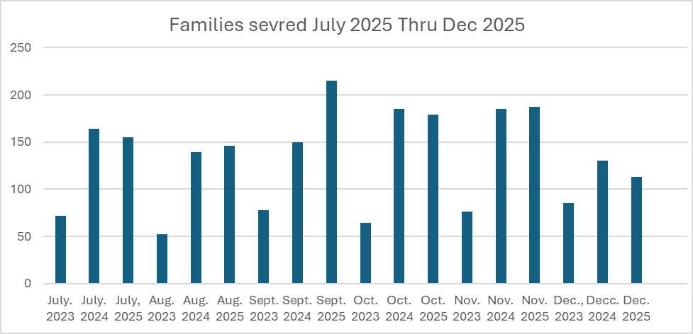

2025 Annual Report- christian education
Jennifer Best

In Sunday School, we start each class with snack. If they finish snack early, there are coloring and activity pages, aligned with the lessons, available. We’ve continued using the Lift Curriculum, an internet-based course with monthly themes. It includes our weekly Sunday School lessons, with a short video lesson, games, and music. We also incorporate fun, hands-on activities. The curriculum is easy to use for teachers and has been well received by our students. We have about 6 students on average in attendance each week, from age 3 to grade 3. Sunday School is led by Jen Best, Suzanne Malys, and Lisa Murtha. We would like to have at least one more volunteer as a substitute so if someone is sick we don’t have to cancel classes. If you’re interested in volunteering, please see me!

We continued the children’s message during the services on the 3rd Sunday of the month. The messages are summaries of the monthly themes we learn about during the Sunday School classes.

The Youth Group is formed from the middle school age group, led by Michelle Logan, and the senior high/college group, led by Nickolas Mason. In the 2024-2025 year, we merged these classes because we only had 1-2 people coming between the 2 classes. In the 2025-2026 year, we only had 1 person consistently coming, but her family member told us that as she was the only one here, it made her feel awkward and has decided to stop coming.

The confirmation class is led by Pastor Krenz. This year, Ariana Berry was confirmed on 6/22/2025. There are no confirmands for the 2025-2026 school year and Pastor Josh is looking at revitalizing the curriculum.

Our Adult Sunday School Class theme for 2025-2026 is Creeds and Councils of the Early Christian Church. It covers the history of the Nicene Creed and the 1st few ecumenical church councils.

Fundraisers: During the 2024-2025 school year, the Youth Group held a Purse Bingo fundraiser in collaboration with Evangelism. The Christian Education fundraisers were the Easter candy sale, which raised a little over $100. Due to lack of youth and interest, the sub sale was cancelled. We started our 2025-2026 school year off with a September Soup Sale, which raise about $130.

Events: During our 2024-2025 school year, in February, we had our bowling event in collaboration with Evangelism. In March, we had a pajama party. In April, we cancelled a swimming event at the Y due to lack of participation. During the 2025-2026 school year, in August, we took a trip to Brant’s Apple Orchard. We partnered with Evangelism for the Candy Crawl in October. In December, we had a Christmas Party. We look forward to new and upcoming events as the year continues.
We completed our Monthly Ministry Focus (MMF) from the 2024-2025 school year. All were welcome to attend to learn more about the different ministries of GSLC. It lasted about 15-45 minutes, depending on participation. Each month, we focused on a different ministry: what each ministry does, why it’s important, how it helps others, and if the Holy Spirit is calling you towards that ministry, what you can do to help.
January, Pastor showed us all the various things the worship ministry includes.
February, Stacy Racut, Greg Betteridge, and Chris Murtha discussed the financial ministries.
March, 3Ms discussed the maintenance ministry.
April, Michelle Logan discussed the social ministry.
May, Mark Lytle and Janelle Cole discussed the gardening ministry.
I send my deepest appreciation and gratitude to all our dedicated Sunday School teachers and volunteers!
Thank you all for your support and commitment to our students and to this ministry!

2025 Annual Report- Vacation Bible School
Jennifer Best

Volunteers: Michelle Logan, Joanne Mechling, Glenda Betteridge, Susan Combs, Michelle Flower, Greg Betteridge, Don Cowey, Jim Fuller, Amy Gallagher, Wes Combs, Jen Best, Pastor Krenz, Lisa Murtha

VBS was June 17-19th from 5-8pm. We had 6 children in attendance. The theme was “What a Mess!” We learned that no matter how messy we are, Jesus loves us; we’re all children of God; and to forgive and love each other. We started each evening with a meal. Then we moved on to activities: arts and crafts, large motor, and music. We ended with bible discussion and debriefing. We allotted a half hour for each activity with 5-minute transition times between each one. It seemed like that was a little too long, so next year, we’re cutting the times to 20 minutes each. The order of events seemed to work well, and it will most likely be the same again next year.

I want to give a huge shout out to everyone who volunteered because it would not have been possible without them! Everyone had such wonderful ideas, from what to eat, to what games to play, to what to sing, what to create, and how to connect the bible lessons to everyday life. I hope that everyone will be willing and available to join us again next year. For 2026, VBS is tentatively scheduled for June 16th-18th.

2025 ANNUAL REPORT- SOCIAL MINISTRY
Pearl Ann Curtis/Michelle Logan

- Funeral Lunches: John Chapin, Jim Monday
- Organized Lenten soup and sandwich suppers
- Fish Dinner/D-Day weekend
- Church Picnic
- Hanging of the greens
- Nisua Bakes
- Attended council meetings
- Quilters finished 66 quilts and they were delivered by Wes and Susan Combs

2025 Annual Report- quilting
Carol Allds

Good Shepherd’s quilting mission aims to help our local community in time of need and to share globally through Lutheran World Relief distribution. We are truly grateful to all who contributed in any way to this mission.
Caring hearts and helping hands gave us opportunity to meet Tuesday mornings (9a.m.-11a.m.) from September 2024 through May 2025. We averaged 9 faithful workers weekly and completed a total of 66 quilts. Our donation to Lutheran World Relief totaled 13 boxes containing 52 quilts. Those quilts were lovingly transported to the LWR annual ingathering at Jerusalem Lutheran Church in Seville, OH October 20, 2024, by Wes & Susan Combs. One quilt was donated to Good Shepherd’s annual fall Basket Raffle, one to a high school graduate, and 10 were given to the church’s adopted families for Christmas. Several quilts were sold to interested parties. A quilt raffle was introduced to give opportunity for people to view some of the quilt creations and participate in the cost of the mission through ticket purchases. Quilts were raffled in December 2024 and January 2025 with proceeds going to the quilting fund for purchase of batting.

We were truly blessed through:
- Prayers for our mission
- Table set up and take down by all who volunteered
- Transfer of funds from Nisua sales and from Mutual Ministry
- Private monetary donations
- Thrivent funds generously given by several individuals and earmarked for the purchase of batting and backing fabric

We welcome you to become part of the mission to bless others through the comfort of quilts!

2025 Annual Report- nisua
Suzanne Malys

October 26, 2025
In September 2009 the Nisua Group was started with Shirley Brookhouser, Heidi Parkomaki, Sue Chapin, Pearl Ann Curtis, Pam Deemer, Dianne Young, Phyllis Waid, Duffy Guthrie & Budd Brookhouser.
The first year we only made 155 loafs. Back then we only did single batches until we tried to see if the new mixer would handle a double.
Duffy and Phyllis got the proofer in 2010 (have no record of cost or origin)
When I gave up books in December in 2024 we had made 10,503 loafs paid for to date.
We purchased the convection oven in 2011 from Lowe’s for $1,118.45
As of 2017 we had paid $21,500 to pay off the building loan on the new addition.
We purchased the new mixer in 2018 from Andy’s Equip (Erie) for $4,700 (after $1,000 trade in old mixer)
-Budd

The nisua crew has been baking every two months with an average of 120 loaves. Balance as of the end of 2025 was $2006. We have welcomed several new bakers to our team, which is great! We have different times volunteers come in to break up the work load:
5am- start up group
8am- kneaders and braiders
9:30 - noon bakers
10am- baggers
Noon-2- clean up
We appreciate all your support. Come join us and learn the process. There’s a video on you-tube produced by Julie Curtis: https://www.youtube.com/watch?v=WBJQZBFLrdw Take a look 👀
Kiitos

2025 Annual Report- property
- Water leak in sanctuary (Burdick II)
- Mowing grass; taking care of yard/garden; and maintaining the equipment (Ron Young, Wes and Susan Combs, Mark Lytle, Janelle Cole, Suzanne Malys, Pastor)
- Cleaned gutters (Jerry Lampela and Gary Anderson)
- General maintenance (Pastor)
- Installed replaced the dampener (Burdick II)
- Replaced a valve in women’s bathroom (Burdick II)
- New water supply valves in the boiler room (Burdick II)
- New shed (Scott Racut)
- Parking lot beautification: new signs (Wes Combs, Pastor)
- New water bottler filler (Pastor, Burdick II)
- New computers (Pastor)
- Stained Glass Project (Willet)
- Detroit St house inspection and measurements (Mark Lytle, Greg Betteridge, Pastor)
  - Congregation elected Detroit St to become parsonage
- Sandusky St sale (Michelle Logan, Nick Nelson, Analynn DiFilippo, Sue Horvath)
- Hired Rags, Brooms, and Mops for custodial services
2025 ANNUAL REPORT – FINANCIAL SECRETARY
Ministry Chairperson: Clarissa Murtha
- 2025 marked my 27th year as Financial Secretary for the church. Duties include recording, depositing, and posting your offerings and sending statements to you. We also provide council with a monthly income report. Please use your name or number on all offering to help us record it accurately.
- It would be helpful if you could print your name on any offering so we could make sure it can be recorded accurately.
- I would like to especially thank Jan Uveges and Robin Bryant for faithfully coming to the church every week to count offering.

Goals:
- Continued support in the ministries of the church.
- May our offerings reflect our blessings in 2026.
- If you have any questions concerning your offering, please contact the church office.

2025 ANNUAL REPORT- ENDOWMENT COMMITTEE
Greg Betteridge, Chairperson

The Endowment Committee made several recommendations to the GSLC church council and congregation and purchase authorizations for items and projects that are necessary for the continued upkeep and modernization of our building and physical assets.

A bottle fill station was purchased and installed to help reduce the number of single use water bottles used by congregants and participants in the various groups that use the church facilities. The unit is located at the drinking fountain by the kitchen and was purchased for $1,867.98 from the Capital Improvement Fund.

In an effort to make the church's parking facilities as convenient as possible for members and guests, the committee authorized up to $2,000 for new signage along with the necessary metal posts, hardware, and a bicycle rack from the Capital Improvement Fund. These were purchased for $1,784.57.

Five hundred dollars from the Mission and Education Endowment Fund was approved to Hopewoods Outdoors for the assistance they provided for the GSLC mission statement.

Up to $1,000 was authorized for purchase of a desktop tower for the AV system in the Sanctuary.

The committee proposed to split the cost of service on the hand bells with the Abiding Memorial Committee. The quoted prices were $2,740 for essential service and $4,500 for a complete refurbishment.

An amount not to exceed $13,000 for the purchase/construction of a maintenance equipment garage was proposed to and approved by the congregation at the February 2025 Congregational Meeting.

At the May 18, 2025 Special Congregational Meeting, the Endowment Committee proposed the purchase of solar panels to help reduce the church electric bill. The total cost was quoted at $121,688 with $48,675 available in Federal tax credit. The proposal was approved.

Changes to the Capital Improvement Fund Endowment by-laws were presented and discussed at the May 18, 2025 Special Congregational Meeting. The congregation approved the proposed changes including allocations of up to thirty percent of the operating budget for operational expenses to offset the short-fall in offering.

The process to move the invested funds from Vanguard Investments to Morgan Stanley Wealth Management was completed.

2025 ANNUAL REPORT –TREASURER
Stacy Racut

GSLC CONSOLIDATED BALANCE SHEET

ASSETS

CURRENT ASSETS DECEMBER 31, 2025
General Fund (including Sunday school) $ 101

GENERAL SAVINGS
Education 262
Bulletins, Altar Flowers, Memorial Candle – Savings 1,679
Abiding Memorial 5,764
Detroit Street 1,012
Sandusky Street 6,887
Youth Mission 8,484
Continuing Education 175
Miscellaneous Other Savings Accounts 18,428
TOTAL CURRENT ASSETS $ 42,792

LONG TERM ASSETS
Mission & Education Endowment Fund: Investment Portion $ 130,564
Capital Improvement Endowment Fund: Investment Portion 1,022,957
Community Support Fund 46,247
Thrivent Fund 16,328
TOTAL LONG TERM ASSETS $ 1,216,096

FIXED ASSETS
Land $ 294,000
Church Building 1,207,500
Other Buildings 11,675
Parking Lots 42,000
LED Sign 50,000
Furniture and Fixtures 131,250
Office Equipment 7,350
Pipe Organ 253,575
Pianos 18,900
Hand Bells 8,295
Digital Keyboard 8,925
Art Glass Windows 88,515
Stained Glass – The Good Shepherd 250,000
472 Detroit Street 60,000
Carillon 14,700
TOTAL FIXED ASSETS $ 2,446,685
TOTAL LONG TERM ASSETS 1,216,096
TOTAL CURRENT ASSETS 42,792
TOTAL ASSETS $ 3,705,573

LIABILITIES AND NET WORTH

LIABILITIES

Property Taxes (Church, Detroit Street, Sandusky Street) $ 1,125
4th Quarter 2025 Accruals (Payroll taxes) $ 1,578

TOTAL LIABILITIES $ 2,703

NET WORTH $ 3,702,870

NET WORTH AND LIABILITIES $ 3,705,573

GSLC GENERAL FUND INCOME & EXPENSE STATEMENT

INCOME ACCOUNTS DECEMBER 31, 2025

GENERAL FUND INCLUDING SUNDAY SCHOOL
Weekly Offerings $ 111,285
Special Offerings 2,175
Other Income 10,296

TOTAL $ 123,756

EXPENSE ACCOUNTS

GENERAL FUND
Christian Education including Sunday school $ 1,228
Worship and Music 1,222
Stewardship 7
Staff Salaries 98,569
Staff Benefits 26,333
Property 42,468
Utilities (Annual)
Electricity 10,349
Gas 5,561
Water & Sewer 958
Telephone 1,018
Property Insurance 8,166
Other Property Costs 16,416
Parish Administration 6,547
Other 2,277

TOTAL GENERAL FUND EXPENSES $178,651

ESTIMATE OF MISSION FUNDING

Christian Education | 2025 Budget | 2026 Budget | Difference
Sunday School | $1,300.00 | $1,200.00 | -$100.00
Vacation Bible School | $0.00 | $0.00 | $0.00
 | $1,300.00 | $1,200.00 | -$100.00
Worship and Music
Worship Supplies | $1,800.00 | $1,000.00 | -$800.00
Maintenance - Music Equip. | $1,100.00 | $1,100.00 | $0.00
Supply Pastor (@$220) | $980.00 | $885.00 | -$95.00
Guest Organists | $300.00 | $300.00 | $0.00
Altar Guild | $200.00 | $200.00 | $0.00
 | $4,380.00 | $3,485.00 | -$895.00
Stewardship
Offering Envelopes | $0.00 | $0.00 | $0.00
Hospitality | $0.00 | $0.00 | $0.00
 | $0.00 | $0.00 | $0.00
Staff Salaries | $100,131.92 | $98,212.27 | -$1,919.65
Staff Benefits
Pastor's Benefits | $17,127.00 | $17,574.00 | $447.00
Pastor's Auto Expense | $1,100.00 | $800.00 | -$300.00
Professional Expense | $350.00 | $200.00 | -$150.00
Continuing Education | $700.00 | $700.00 | $0.00
FICA - Pastor | $4,973.00 | $5,179.05 | $206.05
FICA - All Others | $2,687.59 | $2,334.19 | -$353.40
Workers Compensation | $350.00 | $300.00 | -$50.00
Pastor's Cell Phone | $540.00 | $480.00 | -$60.00
 | $27,827.59 | $27,567.24 | -$260.35
Property
Hall Usage Refund | $0.00 | $0.00 | $0.00
Janitorial Supplies | $800.00 | $7,510.00 | $6,710.00
Maintenance - Building | $5,000.00 | $6,000.00 | $1,000.00
Safety/Security | $900.00 | $1,500.00 | $600.00
Electricity | $10,000.00 | $7,800.00 | -$2,200.00
Gas | $5,000.00 | $7,000.00 | $2,000.00
Water & Sewer | $740.00 | $850.00 | $110.00
Trash Removal | $715.00 | $715.00 | $0.00
Snow Removal | $3,000.00 | $3,000.00 | $0.00
Insurance | $8,300.00 | $9,296.00 | $996.00
Telephone | $600.00 | $600.00 | $0.00
 | $35,055.00 | $44,271.00 | $9,216.00
Parish Administration
Office Supplies | $1,300.00 | $2,100.00 | $800.00
Pastor's Discretionary | $600.00 | $600.00 | $0.00
Postage | $1,000.00 | $800.00 | -$200.00
Maint - Office Equip. | $2,400.00 | $0.00 | -$2,400.00
Copier Contract | $0.00 | $0.00 | $0.00
Internet Service | $1,200.00 | $1,200.00 | $0.00
Software & Licenses | $600.00 | $1,900.00 | $1,300.00
Automated Call | $600.00 | $600.00 | $0.00
 | $7,700.00 | $7,200.00 | -$500.00
Finance
Finance Charges | $30.00 | $30.00 | $0.00
Bank Fees (checks/deposit slips) | $0.00 | $0.00 | $0.00
 | $30.00 | $30.00 | $0.00
Congregational Council
Synod Assembly Fees | $700.00 | $850.00 | $150.00
Administrative Expense | $300.00 | $150.00 | -$150.00
Benevolence (5% giving) | $15,000.00 | $5,000.00 | -$10,000.00
 | $16,000.00 | $6,000.00 | -$10,000.00
Grand Total | $192,424.51 | $187,965.51 | -$4,459.00

